Mother country address:  Tambo – Bani Mazar  Elminia  Egypt  Mobile: 00966569735445  Mobile home:-  00966540637918 |  | 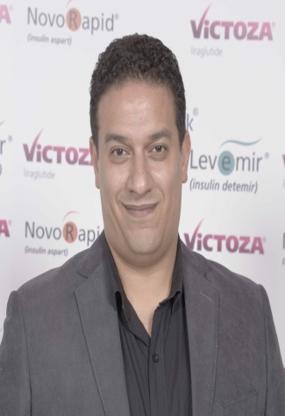  Mahmoud Abdelaziz Mohamed | Current address :  Saudi German Hospital  Jeddah  Saudi Arabia  E-mail:-  mahmoud.motawea@yahoo.com  mahmoud.motawea35@gmail.com
Education &Qualification: | 6/2006 Master Degree (M.Sc) in Internal Medicine Faculty of Medicine Elminia University - Egypt  12/2001 (M.B.B.CH) Faculty of Medicine Elminia University - Egypt  1994/1995 Egyptian (G.C.S.E), Science
Employment History | 12/2006 - Current Gastroenterology, Endoscopiest – Internal Medicine Department Saudi German Hospital- Jeddah Saudi Arabia  9/2006 - 12/2006 Assistant specialist Internal Medicine Department Matai Hospital – Elminia Egypt  3/2003 - 3/2006 Residence of Internal Medicine Internal Medicine Department Elminia University Hospitals Egypt  3/2002 - 3/2003 House Officer Elminia University Hospitals Egypt
Professional Experiences | - House Officerin Elminia University Hospitals – Egypt (3/2002 – 3/2003).  - Residenceof Internal Medicine in Internal Medicine Department  ,Elminia University Hospitals, Egypt : (3/2003 – 3/2006).

Professional Experiences  (Cont...) | - Experience in G.I endoscopies either diagnostic or therapeutic,  Assisting in E.R.C.P procedures (G.I Endoscopy Unit, Internal  Medicine Department, Elminia University Hospitals, Egypt; :  (2004 – 2006).  - Working now as Gastroenterology &Endoscopy specialist,  Endoscopy Unit – Internal Medicine department, Saudi German  Hospital - Jeddah , Saudi Arabia. Performance most of  the endoscopy procedures either diagnostic or therapeutic, with  experience in Esophageal pH-Metry and Manometery; : (12/2006 –  up till now).  DETAILED EXPERIENCED IN GI ENDOSCOPY:-  • Performing diagnostic and therapeutic gastrointestinal endoscopic  procedures including ERCP:-  * Upper GI Endoscopy : Diagnostic and biopsy taking  * Injecting oesophago - gastric varices : Elective and emergency  * Inserting metal stent for oesophago - gastric tumours or strictures  * Application of gastrostomy tube for feeding  * Laser or Argon beam ablation for oesophago gastric – lesions  * Colonoscopy : Diagnostic and Therapeutic  * Polypectomy for gastric or colonic polyp  * ERCP including sphincterotomy, biopsy , CBD dilatation and /  or stent insertion, stone extraction
Skills | Language - Arabic (Mother tongue). - English (Fluent written and spoken).  Internet - Excellent  Computer - Excellent knowledge with Microsoft systems.
Personal Data | - Marital status: Married  - Date of birth:10th of January 1978
References | 1. Prof. Ahmed Hashem – Director of endoscopy unit  Saudi German hospital-Jeddah branch;KSA  Assistant professor of Gastroenterology & Hepatology , Cairo University; Egypt.  e-mail:- Endoscopy1.jed@sghgroup.net  2. Ihab Ahmed - Head of Internal Medicine department  Saudi German hospital-Jeddah branch.  e-mail:- Im1.jed@sghgroup.net  3. Prof. Ibrahim Motawea - Prof. of Gastroenterology & Hepatology Helwan University; Egypt.

